Name: Conkright_Lab 4
Lab Partner(s): Gianna Cassas, Joshua Marks, and Ashley Mccallum
Diffusion and Osmosis Lab

Introduction

Background Information:
- Why is the cell membrane said to be “semipermeable”? The cell membrane is said to be “semipermeable” because the cell membrane is selective to what it lets goes in and outside of the cell.
- Differentiate “active transport” and “passive transport”. Active transport is a type of transport that requires energy (ATP) and moves against the concentration gradient. Passive transport doesn’t require energy and moves from an area of high concentration to an area of low concentration.
- Explain the concept of diffusion. Use an example in your explanation. Diffusion is the random movement of molecules or other particles from a higher concentration to a lower concentration and is a form of passive transport. Example, A drop of food coloring in a glass of watercolors the water through diffusion. The dye molecules slowly spread evenly through the liquid, creating one particular shade.
- Define osmosis. Use blood cells to explain the terms isotonic, hypertonic, and hypotonic, in terms of comparing solutions on either side of a semipermeable membrane. Osmosis is a type of diffusion that water moves across a cell membrane. Does semi permeable membrane of a blood cell in an isotonic solution allows water to flow in and outside the cell membrane at equal rates so there is no net fluid movement. The semipermeable membrane of a blood cell in a hypertonic solution. The water is not permeable through the membrane so water is only exiting the cell. The semipermeable membrane of a blood cell in hypotonic solution. The water is permeable through the membrane which causes the cell to fill with water and burst.
- Why is the concept of water potential used? What are potential is what allows water to get in to a plants roots when there’s more so you within the cell then water in the soil.
- What formula is used for calculating solute potential (identify i, C, R, and T)? The formula used for calculating saw your potential is iCRT. This is the ionization constant, concentration(moles per liter in concentration),pressure constant(0.0831 liters bars/moles K) and temperature in kelvin
- Why does the water potential decrease when a solute is dissolved in water? Solutes reduce the water potential by consuming some of the potential energy available in the water
- What is a rule for the “net movement of water”? The net movement of water is in the direction of increased solute concentration.
- Situation: A potato cell is placed in pure water. Assigning a value for the solute potential of the potato as -9 bars, explain whether or not water will diffuse into the cell.
- Situation: A potato cell (-9 bar) is placed in a cup of water that has a solute dissolved (-15 bar). Explain what will happen to the cell, why, and the term for this.
- Describe plasmolysis. Explain the difference between a plasmolyzed cell and the same cell that is not plasmolyzed. How does plasmolysis affect plant cells in a real-life situation?
Plasmolysis is the contraction of the protoplast of a plant cell as a result of loss of water from the cell.

Research Questions:

Part 1:What effects does plasmolysis have on Anacharis?
Part 2:How does solute concentration affect the initial and final mass of a dialysis tube over a 24 hour time period ?
Part 3: How does diffusion and osmosis work?
Part 4: How does salt water affect celery?
Part 5: How does the size of the cell affect the rate of diffusion ?
Part 6: How does the solute concentration of sucrose affect the water potential of carrots?

Hypotheses:

Part 1: Plasmolysis will cause the cytoplasm to shrink in the Anarchris.
Part 2: The more solute concentration the greater the change in the initial and final mass.
Part 4: The celery will absorb the salt from the salt water and lose mass.
Part 5: The larger the cell the greater the decrease in the rate of diffusion
Part 6: The green solution will have the greatest

Methods:

Materials:
Part 1:
- Anacharis plant
- Forceps
- Microscope slides
- Cover slips
- Distilled water
- Salt water
- Light microscope
- Paper towels
Part 4:
- Celery stick soaked in water
- Celery stick soaked in salt water
Part 5:
- 3 Phenolphthalein agar cubes: 3x3cm,2x2cm,and 1x1cm
- 1 Plastic knife
- 1 Plastic spoon
- 1 Plastic cup
- 1 Metric ruler
- 100 ml White vinegar
- Timer
Part 6:
- 1 Graduated cylinder
- 6 Plastic cups
- 150 ml Red mystery solution
- 150 ml Orange mystery solution
- 150 ml Yellow mystery solution
- 150 ml Green mystery solution
- 150 ml Blue mystery solution
- 150 ml Violet mystery solution
- Baby carrots ,6 per group
- 1 digital balance

Procedure:
Part 1:
- Using the forceps, remove one single Anacharis leaf from its stem and place it gently on a clean microscope slide.
- Add two drops of distilled water to the slide and cover with a cover slip.
- Examine the leaf at 40X magnification and note the characteristics of the cells. In your lab notebook, draw several cells that show a good representation of the cells you observed. In your drawing, label the cell wall, cell membrane, cytoplasm, and chloroplasts.
- Remove the slide from the microscope; blot excess liquid from the leaf. Add two to three drops of salt water across the leaf sample. You can put the salt water on one side of the cover slip and place paper towel on the opposite side of the cover slip to wick the salt water by capillary action across the leaf.
- Allow the slide to sit for two to three minutes in the solution and reexamine the leaf under the microscope at the same magnification.
- Note the appearance of the cells. In your lab notebook, draw several cells that show a good representation of the cells you observe. In your drawing, label the same structures you labeled in #3, above.

Independent and Dependent Variable Identification:

Concentration of sucrose solution

Constants:
Temperature
Pressure

Control:

Time of soaking
Part 4:
- Break one celery stick soaked in water and one celery stick soaked in salt water.

Part 5:
- Obtain agar cubes in a plastic cup from your teacher. Be careful not to scratch the surface of the cubes or touch the surface of the cubes too much.
- Using the metric ruler, measure the dimensions of each agar cube and record the exact measurements in your lab notebook.
- Place the 3 cubes carefully in a plastic cup. Add white vinegar (acetic acid) until the cubes are covered/ submerged. Using a plastic spoon, keep the cubes submerged for 10 minutes turning them as needed. Make sure the cubes are not touching. Be careful not to scratch the surface of the cubes. Be sure to start the timer once the cubes are submerged.
- As the cubes soak, calculate the surface area, volume, and surface area to volume ratio for each cube. Record this data in your data table provided. 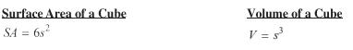
- After 10 minutes has elapsed, use a spoon to remove the agar cubes and carefully blot them on a paper towel. For more accurate measure of diffusion, use a knife to cut the cubes in half.
- Using a metric ruler, measure the distance in centimeters (cm) that the white vinegar diffused into each cube. Record this as distance from the surface. (You are essentially measuring the distance in cm from the edge of the white edge of the cube to the edge of pink in the cube.)
- Calculate the rate of diffusion for each cube in centimeters per minute (cm/min).
- Calculate the volume of the portion of each cube which has not changed color (in other words, the portion of the cube that is still pink).
- Calculate the extent of diffusion into each cube as a percent of the total volume.

Extent of diffusion = Total cube volume - Volume of cube that has not changed color X 100
Total cube volume
- Graph the rate of diffusion (cm/min, y-axis) relative to surface area to cell volume ratio (1/cm, x-axis).
- Graph the extent of diffusion (y-axis) relative to surface area to cell volume ratio (1/cm, x-axis).

Part 6:
- Cut three baby carrots in half.
- Mass each baby carrot piece. Measure the length of each piece of baby carrot.
- Record the mass and length of each baby carrot piece. Keep track of which baby carrot pieces have which mass and length - don’t mix them up!
- Place one piece of baby carrot in each of the 6 mystery sucrose solutions. Record your observations when you put them in.
- Wait 30 minutes.
- After 30 minutes, re-mass the cores and calculate the changes in their masses. Record your data.

Diagram/Image of procedure:

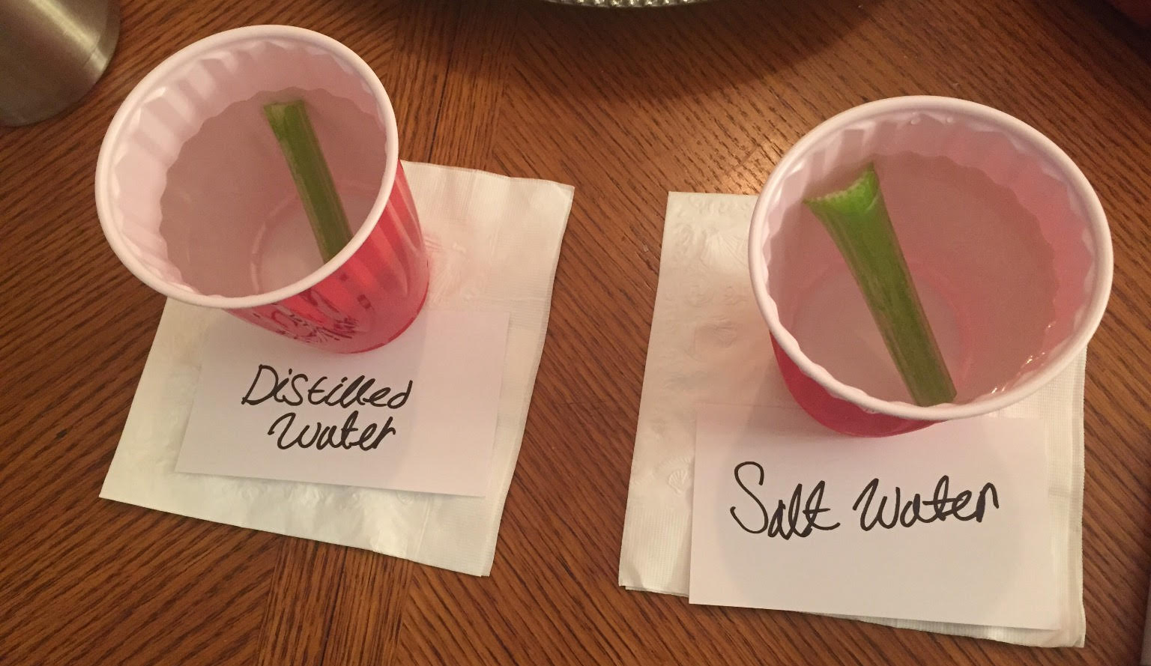
Celery Sticks soaked in water and in salt water respectively

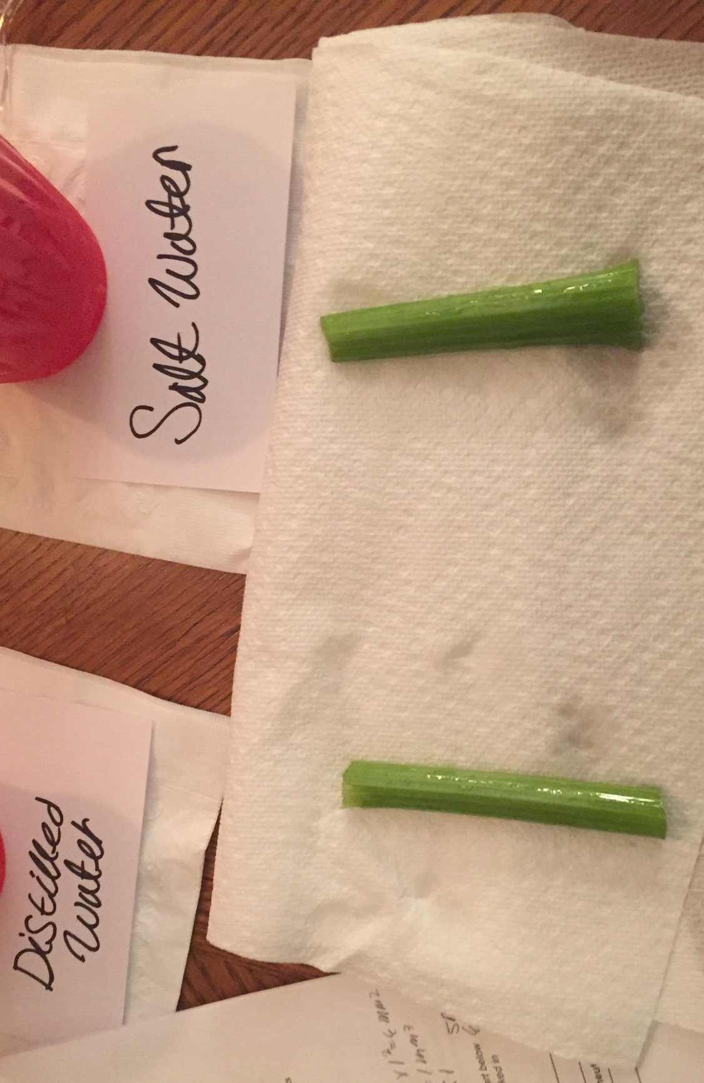
Celery Sticks after being soaked in water and in salt water respectively

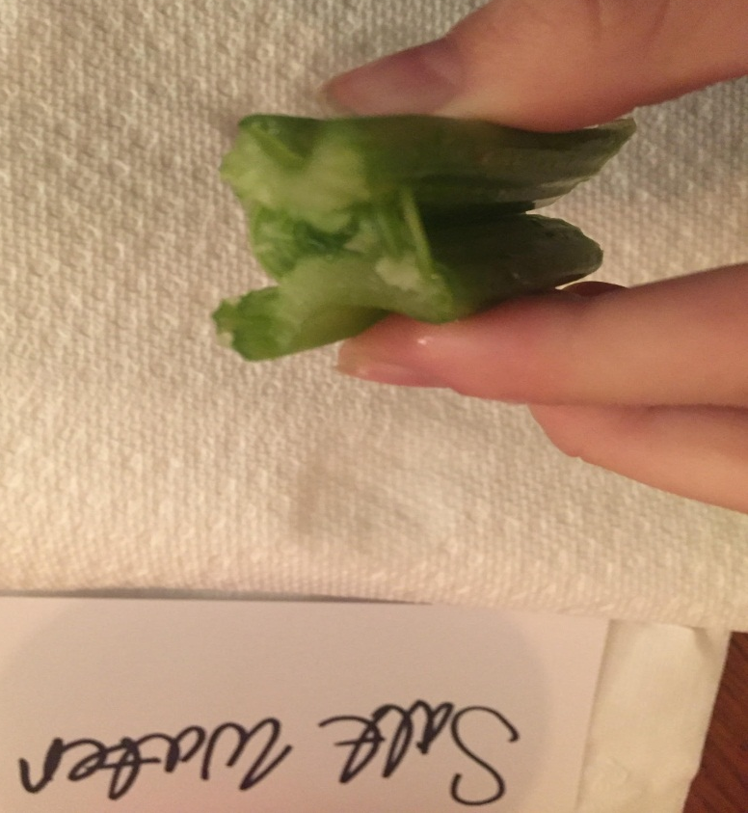
Break Celery Stick soaked in salt water
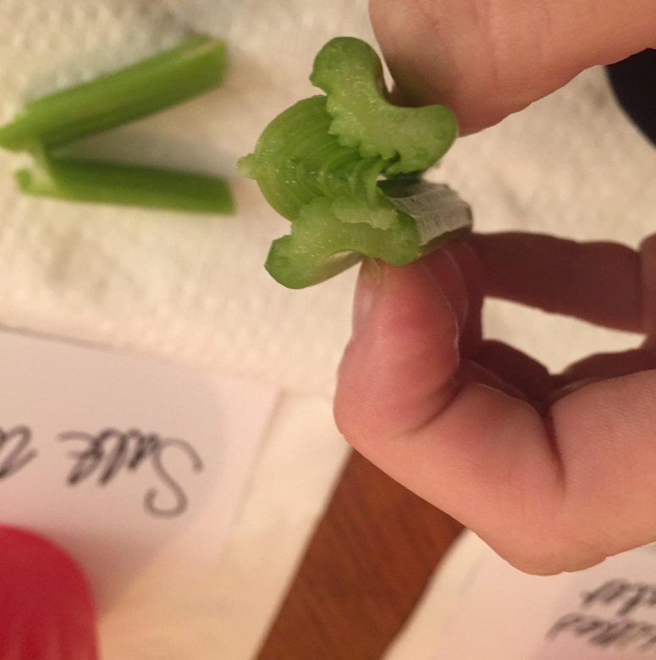
Break Celery Stick soaked in water
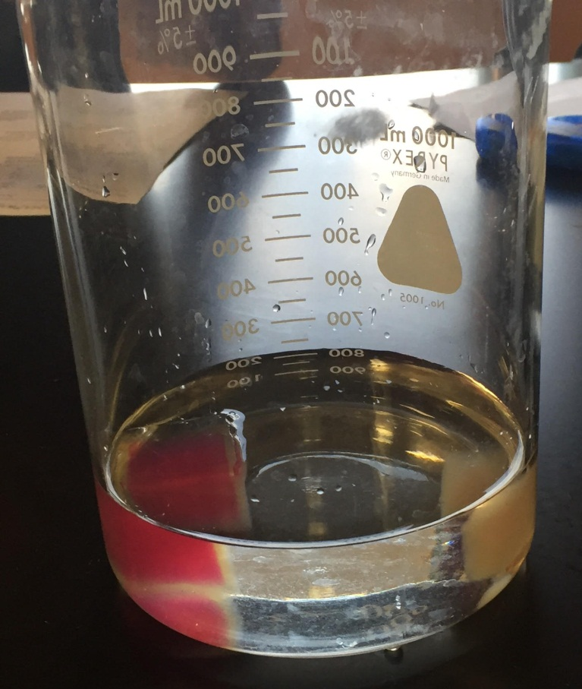
White vinegar
Agar cube
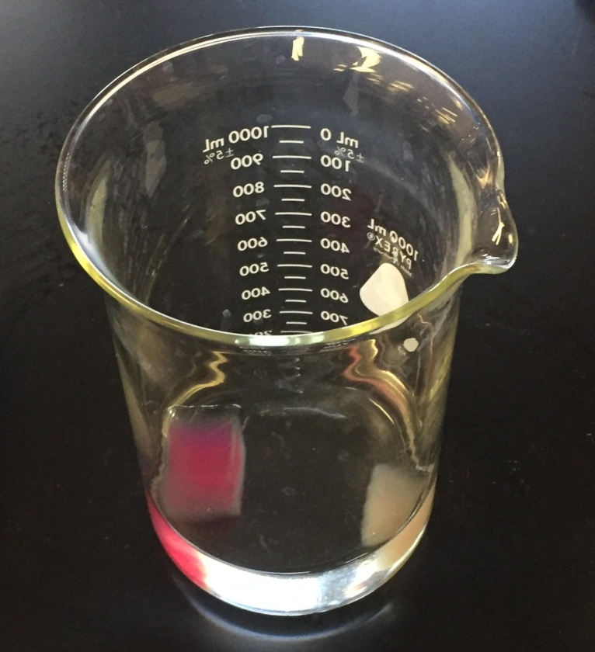
Agar cubes soaked in vinegar
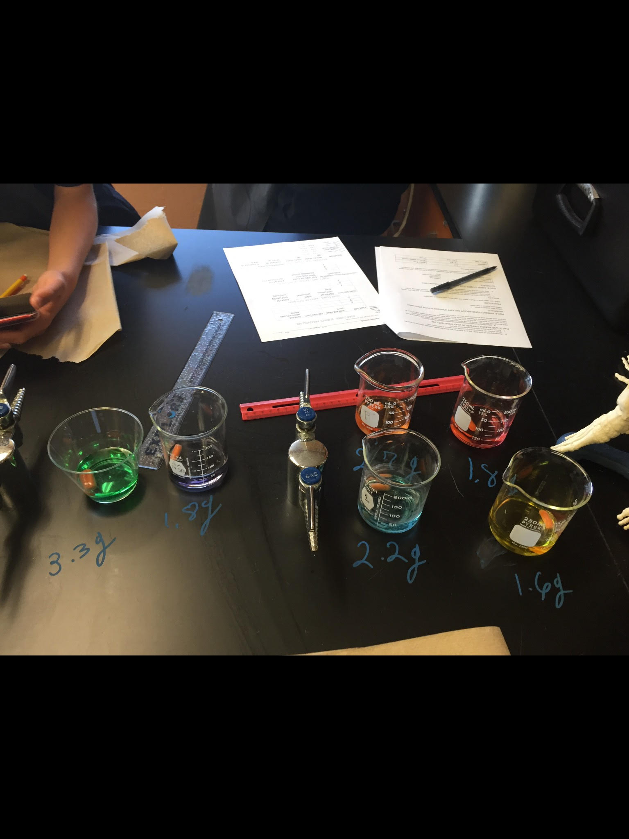
Baby carrot
Mystery solution
Baby carrots dipped in 6 different mystery sucrose solutions

Results:

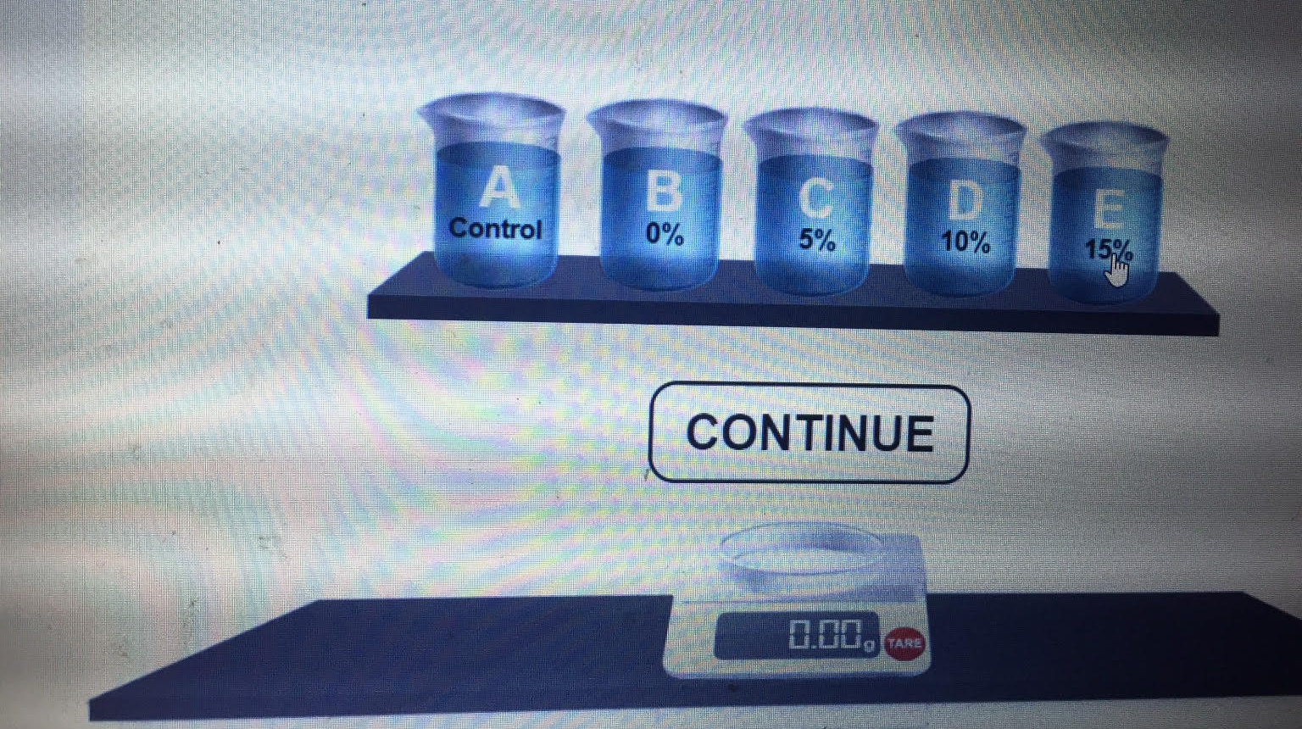
Cell Homeostasis Virtual Lab

Qualitative Data:

Figure:
Initial and final masses of each dialysis tube
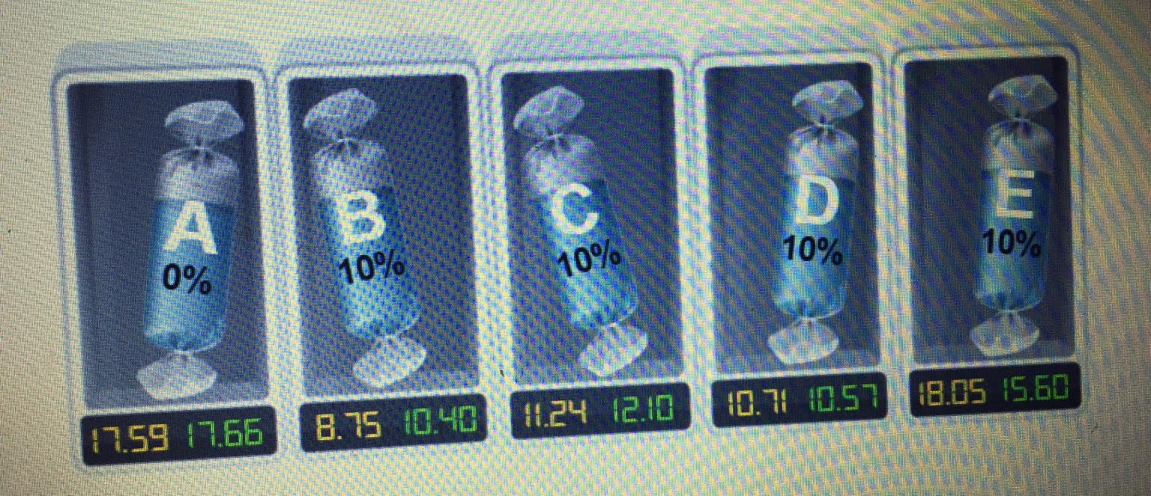

Part 5.
- Because the smaller dimension has less surface area it has the fastest effusion rate so there’s less surface area to be the defuse
- The 3 x 3 Igor cube support of the greatest diffuse percentage total in volume be at 98% because it took the longest to defuse
- As the agar cube got larger the diffusion rate also increased as well and as the diffusion rate increase soda the cell volume relative to the surface area and the same goes for vice versa
Table:

AGAR CUBES – SURFACE VOLUME
CUBE SIZE | SURFACE AREA (cm²) | VOLUME (cm³) | SURFACE AREA/ VOLUME RATIO
3 | 54 | 27 | 2:1
2 | 24 | 8 | 3:1
1 | 6 | 1 | 6:1

Table:
AGAR CUBES – RATES OF DIFFUSION
CUBE SIZE (cm) | Depth of diffusion (cm) | TIME (minutes) | RATE OF DIFFUSION (cm/min)
3 | 0.4 | 10 | 0.04
2 | 0.28 | 10 | 0.028
1 | 0.30 | 10 | 0.030

Table:
AGAR CUBES – EXTENT OF DIFFUSION
CUBE SIZE | VOLUME OF CUBE THAT HAS NOT CHANGED COLOR | EXTENT OF DIFFUSION (%)
3 | 8 | 70.37
2 | 2.4604 | 64
1 | 0.016 | 48

Table:
MYSTERY SOLUTIONS AND BABY CARROTS
 | SOLUTION | INITIAL MASS (g) | FINAL MASS (g) | CHANGE IN MASS (g) | % CHANGE IN MASS
2.4 | Green | 3.3 | 3.4 | -0.1 | 1
2.6 | Purple | 1.8 | 1.8 | 0 | 0
2.6 | Orange | 2.7 | 2.8 | -0.1 | 1
2.6 | Red | 1.8 | 1.7 | 0.1 | 10
2.4 | Blue | 2.2 | 2.2 | 0 | 0
2.5 | yellow | 1.6 | 1.6 | 0 | 0

Calculations:
Formula1: for calculations of surface area and volumes of agar cubes

Formula 2:
Extent of diffusion = Total cube volume - Volume of cube that has not changed color X 100
Total cube volume

Discussion:

Conclusions:
<Conclusions go here. This is where you form conclusions and make statements about your hypothesis. You can also discuss any experimental error here. Make sure to adhere to all guidelines>

In conclusion, for the following parts;

Part 1: the cytoplasm of the anacharis leaf shrinks in salt water due to movement of water particles from the cytoplasm to the salt water solution. Whilst in distilled water jar, the cytoplasm expands due to movement of water particles from the jar to the cytoplasm through the semi-permeable membrane.

Part 4:

Osmosis and active transport take place in celery cells placed in water and in salt water respectively thus the increase in mass in the earlier and decrease in mass in the later.

Part 5:

The white discoloration by the white vinegar is more evident in the thinnest cube (1x1cm) since there are very fewer cells to be permitted by the acetic acid particles.

Part 6:

The mystery color solutions show different thicknesses of absorption

The solution with the least thickness of absorption carries the most number of sucrose particles. The increased density reduces the rate of absorption by the baby carrot cells.

Experimental Design/Inquiry:

Part 7:
- Potato cubes
- Forceps
- Distilled water
- Salt water
- Clean jars

Procedure:

Using the forceps, obtain potato cubes of 1cm³ and soak them in different jars. Label the jars properly as distilled water and salt water. Time the period of your experiment and record the observation.
Record and analyse your observation.

References:

Appendices:

